Motion and force in a gravitational field

Home Assignment Vectors, Energy and Momentum
Name: ______ ANSWERS _______________ (37 marks total)
Maximum 2 marks to be deducted for incorrect units and significant figures.

- Rain drops falling vertically have a terminal velocity of 4.00 ms⁻¹. They reach a zone in the atmosphere where the wind is blowing horizontally at a constant 6.00 ms⁻¹. At what angle to the vertical do the drops now move? Include a diagram with your answer. (2 marks)

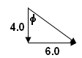
φ = tan⁻¹ (6 ÷ 4)
= 56.3⁰

the drops move 56.3⁰ to the vertical [1 mark]

[1 mark]

- A bird is flying upwards at an angle of 35.0⁰ to the horizontal at a velocity of 2.88 ms⁻¹. What are the vertical and horizontal components of the bird’s velocity? (2 marks)

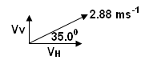
V_{H} = 2.88 cos 35
V_{H} = 2.36 ms⁻¹ [1 mark]

V_{V} = 2.88 sin 35
V_{v} = 1.65 ms⁻¹ [1 mark]

- A baseball travelling at a velocity of 8.00 ms⁻¹ west is hit by the batsman and ends up moving north at a velocity of 9.00 ms⁻¹. What is the resultant change in velocity? (3 marks)
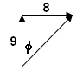
u = 8 ms⁻¹ W v – u = 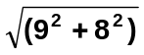
v = 9 ms⁻¹ N = 12.04 ms⁻¹ [1 mark]
v – u = 9 N – 8 W φ = tan⁻¹ (8 ÷ 9)
= 9 N + 8 E = 41.63⁰ [1 mark]

ΔV = 12.0 ms⁻¹ N 41.6⁰ E [1 mark]

- A boat’s speed in still water is 5.00 ms⁻¹. If the boat is to travel directly across a river whose current has a speed of 3.00 ms⁻¹, at what angle to the bank must the boat head? Draw a labelled diagram with your answer. (2 marks)

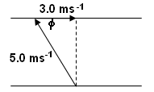
the maximum speed is 5.00 ms⁻¹ so that must be the hypotenuse of the right triangle.

φ = cos⁻¹ (3 ÷ 5)
φ = 53.1⁰ to the bank

[1 mark] [1 mark]

- Consider the diagram of forces shown on the right.
Calculate the total force acting on the object. (5 marks)
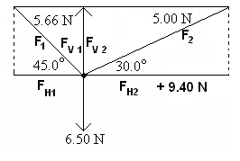
Vertical Forces = 6.50 – [ (5.66 sin 45) + (5 sin 30) ]
= 6.50 – 6.50
= 0 N [2 marks]

Horizontal forces = (5.66 cos 45) – [9.40 + (5 cos 30)]
= 4.00 – 13.83
= 9.83 N right [2 marks]

Resultant = 9.83 N right [1 mark]

- A plane whose airspeed is 55.0 ms⁻¹ heads due north. But a 28.0 ms⁻¹ northeast wind (i.e., coming from the northeast) suddenly begins to blow. What is the resulting velocity of the plane with respect to the ground? (5 marks)

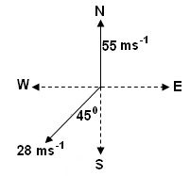
Resolve 28 ms⁻¹ to horizontal and vertical components
V_{v} = 28 sin 45 = 19.79898 ms⁻¹ South
V_{H} = 18 cos 45 = 19.79898 ms⁻¹ West [1 mark]

Vertical velocity = 55 – 19.79898 = 35.201 ms⁻¹ North
Horizontal velocity = 19.79898 ms⁻¹ West [1 marks]
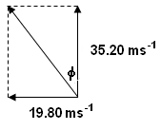
V = 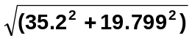
= 40.4 ms⁻¹ [1 mark]
φ = tan⁻¹ (19.8 ÷ 35.2)
= 29.4⁰ [1 mark]

V = 40.4 ms⁻¹ N 29.4⁰ W [1 mark]

- A pitcher throws a baseball due south towards the batter at 20.0 ms⁻¹. The batter just touches the ball but causes it to continue in the same direction but at 15.0 ms⁻¹ still sount. If the ball’s change in velocity occurred in 0.200 s, what was the ball’s acceleration? (3 marks)

u = 20 ms⁻¹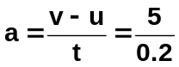 S
v = 15 ms⁻¹ S
v – u = 15 S – 20 S
= 15 S + 20 W a = 25.0 ms⁻¹ West [1 mark value, 1 mark direction]
v – u = 5.00 ms⁻¹ W
[1 mark]

- As I watch out of my study window, I see Gipsy, my Persian cat, chasing a lizard (assume it has a mass of 0.144 kg). The Lizard is running at 3.15 ms⁻¹ N when, coming to a wall, it spins around running straight under Gipsy and is now travelling at 3.80 ms⁻¹ S. What was the change of momentum of the lizard? (3 marks)

u = 3.15 ms⁻¹ N Δp = m (v – u)
v = 3.80 ms⁻¹ S = 0.144 x 6.95
v – u = 3.8 S – 3.15 N Δp = 1.00 kgms⁻¹ South [2 marks]
= 3.8 S + 3.15 S
= 6.95 ms⁻¹ S [1 mark]
m = 0.144 kg

- Tim is riding his bike (total mass of 70.0 kg) at 4.15 ms⁻¹.
- What is Tim’s kinetic energy?

E_{k} = ½ mv²
= ½ x 70 x 4.15²
= 602.7875
E_{k} = 603 J [1 mark]

- How much work must Tim do to double his speed?

Work is equivalent to energy so work = E_{k} [1 mark]

E_{k} = ½ mv²
= ½ x 70 x 8.3²
= 2411.15
E_{k} = work = 2.41 x 10³ J [1 mark]

- Free body diagrams are useful to show the forces acting.
- For the object shown, calculate the net force acting.

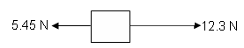
net Force = 12.3 – 5.45 = 6.85 N [1 mark]

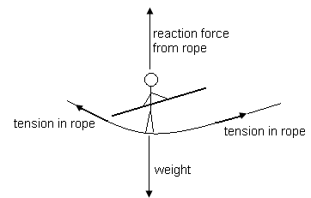

- Label all the forces acting in the following situation. (2 marks)

[2 marks]

- A 0.150 kg ball is thrown straight up into the air at 6.40 ms⁻¹. It leaves the person’s hand 1.20 m from the ground.
- How much kinetic energy does the ball have as it leaves the person’s hand? (1 marks)

m = 0.15 kg E_{k} = ½ mv²
u = 6.40 ms⁻¹ = ½ x 0.15 x 6.40²
= 3.027
E_{k} = 3.03 J [1 marks]

- What is the maximum height the ball will reach assuming no air resistance? (3 marks)

u = 6.40 ms⁻¹ v² = u² + 2gs
v = 0 ms⁻¹ 0 = 6.4² + (2 x -9.8 x s)
g = -9.8 ms⁻² 0 = 40.96 – 19.6s
(opposite direction) 40.96 = 19.6s
s = 2.09 m [2 marks]

but already 1.20 ms in the air so total height
= 2.09 + 1.20
= 3.29 m [1 mark]

- What is the potential energy when the ball is at its highest point? (1 marks)

E_{p} = mgh
= 0.15 x 9.8 x 3.29
E_{p} = 4.84 J [1 mark]

